PRACTICE SESSION 1 ANSWERS:

Part – 1:

1.THE OUTPUT OF THE GIVEN SNIPPET IS:

[10,20,30,40]

[10,20,40]

.

2. true.

3. option d) newlist = list(aLst).

4.only a , b and c is right.

5.comma(,).

6. none.

Part – 2:

1.

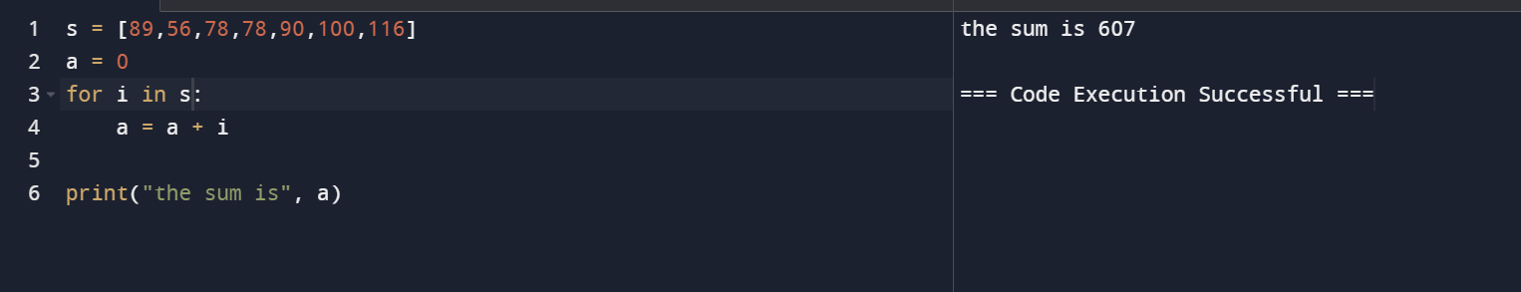

2. 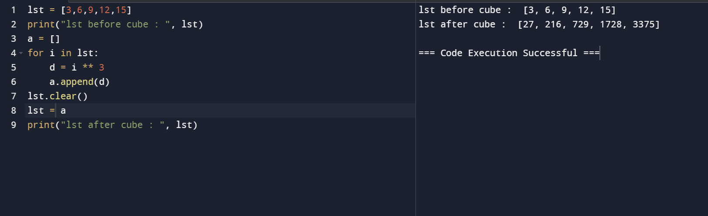

3. 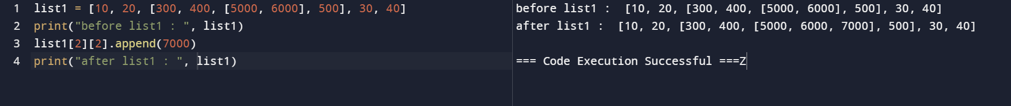

4. 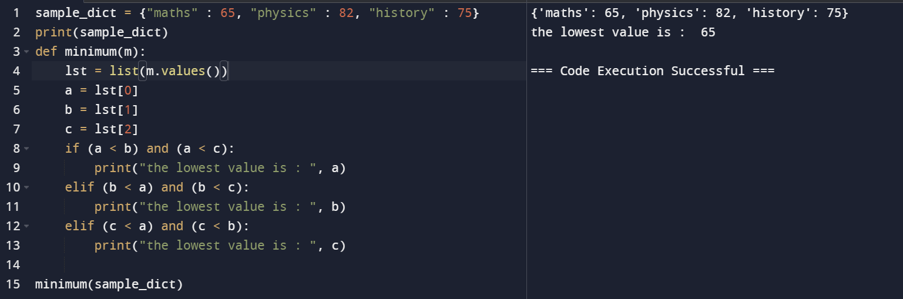

5. 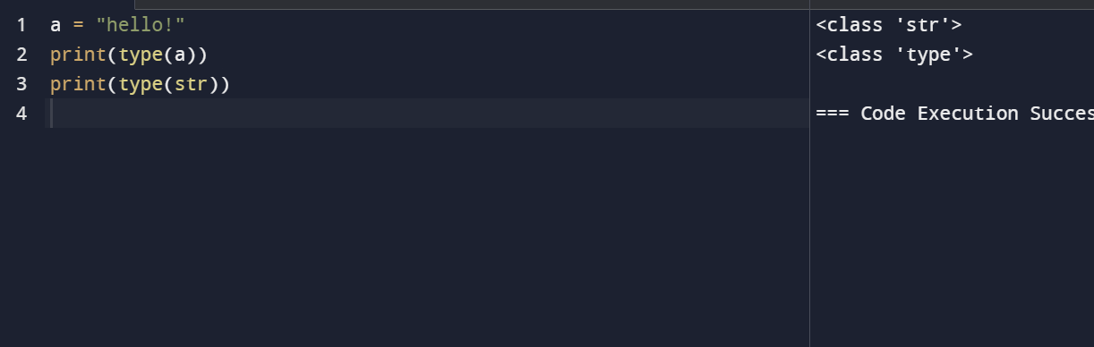

This above image shows that a is a variable and it’s type is str(string). The type of string is type indeed, which means that the str is data type.

Here, the variable a is object and str(string) is the class and type is the metaclass.